The effect of coordination-based video games on reaction time and hand-eye coordination
Joshua Hamza
Chesapeake Bay Governor’s School

ABSTRACT
In my study I conducted trials to determine the effect of video game playing on reaction time and hand eye coordination. This study was conducted as a reaction time study and was assessed using a reaction time measuring task. To start, I had a total of 29 participants take an online baseline reaction time test and record the average of their scores every 5 trials for 25 trials total. Participants then recorded these 5 score averages onto a paper form that was collected. Following the baseline assessment, exactly one week later, participants played a coordination-based video game for six 10-minute sessions spaced between 10 minutes of rest. Participants reaction time scores were then recollected using the same reaction time test. Data was then collected via a scorecard. After data collection improvement scores were calculated by comparing participant baseline and final scores. A paired t test was then conducted to evaluate changes in reaction time. The paired t-test revealed a one tail p-value of 0.125. The test revealed a change in the average time from 288 ms to 281 ms. There was an average decrease of 7 milliseconds between participants. I believe this might suggest some sort of significance in the video game treatment. Although my p-value was above 0.05 so that I cannot reject my null, I believe this study can serve as a pilot study to serve as a guide for future research. While this study did not find statistically significant evidence that playing the coordination-based video game improved reaction time, the observed 7 ms decrease suggests that video game training might have some potential benefits. With improvements to the study design, future research may be able to better determine whether video games can effectively improve reaction time and other cognitive skills.
INTRODUCTION
Despite the widespread use of video games as a form of entertainment, cognitive training studies have shown that their use is an effective way to train and eventually enhance cognitive function in study participants. When used as a training tool rather than a form of entertainment, certain types of video games can train certain cognitive functions. A meta-analysis study concluded that regular game participation can have positive effects on cognitive function in adolescents (Choi et al., 2020). Data reported improved memory, attention, executive function, and motor skill control in participants. It also claims that video games were found to enhance cognitive functions better than conventional methods of learning. The study accredits these benefits to the way video games convey information to the player. The focus of visuospatial awareness in video games is a major factor in the positive effects. In accordance with this, the study also found that games that have a core focus on visuospatial awareness have positive impacts on participant’s cognitive health. Data indicated that players of movement-based games, like players of the game “Beat saber,” have more dorsolateral prefrontal cortex activation and are better at focusing on important information and selective attention. The study also found that video game use can be positively associated with improvement of neural networks in certain regions such as the prefrontal cortex. This is especially beneficial to the elderly, as brain plasticity is tied heavily to one’s ability to learn. This is why I wanted to conduct a study to determine if coordination-based video games have an effect on hand eye coordination.
There is also evidence to suggest that videogame use also improves cognitive function in individuals with mental disabilities. One researcher conducted a study using a narrative-based videogame to improve cognitive function in participants with mild cognitive impairments (Choi, 2025). Data concluded that narrative mobile video game-based training generally improved frontal hemisphere function in patients and improved general engagement in MCI individuals (mild cognitive impairment). Another study used smartphone video games to improve cognitive function in patients with chronic schizophrenia (Shi, 2023). Both the control group and the experimental group were tested in immediate memory, language, and delayed memory. The control group displayed marginal improvements in these areas, while the experimental group displayed improved cognitive function in all areas.
There have even been studies conducted to specifically test the effect of video game-based intervention on mental performance in older adults. A study concluded that video game intervention could be considered as an option for improving general cognitive function and processing speed in the elderly (Yang et al., 2021). Not only are top ranking players better at selective attention than lower ranked players, but that even lower ranked players after one action video gaming session were better at selective attention than they were before (Ahn et al., 2023). This suggests that video games acted as a sort of “warmup” for the brain. Studies like these support the idea of using video games not just as entertainment, but rather as a training tool. Akin to an athlete using weights, video games have the potential to improve your brain with repeated use. These theories are what prompted my study. I wanted to conduct a study to determine if there is a link between repeated video game use and hand eye coordination improvement.. These studies suggested that video game use could enhance cognitive functions like memory, selective attention, and executive function. Given these benefits, I hypothesized that video games could potentially provide benefits to hand eye coordination and reaction as well. This is illustrated in my hypothesis.
Hypothesis
H₀: P_{Before} = P_{After}
My null hypothesis is that reaction time performance stays the same. There will be no difference between group A and group B.
H_{a}: P_{Before} < P_{After}
My alternative hypothesis is that reaction time performance before the treatment will be worse than reaction time performance after the treatment.
P = Reaction time performance
Reaction time performance or “P” will be determined based on the score participants get on the game.
METHODS AND MATERIALS
Procedure
This study was conducted as a reaction time study and was assessed using a reaction time measuring task. The objective of the study was to measure the participants’ ability to focus on a specific visual stimulus and respond as quickly as possible. Materials required for this study included a computer or mobile device, a reaction time–based video game, a quiet testing environment, and a means of recording performance, specifically participants’ scores from the reaction time measuring task.
The study included a sample size of 29 participants. To ensure the collection of meaningful data. Only individuals with normal or corrected-to-normal vision and no known cognitive or un-corrected visual impairments were selected. To protect participant confidentiality code names were assigned by an instructor who was the only one with the key linking aliases to identities. The sample was one of convenience and, as a result, was not representative of the general human population. Because the majority of participants were adolescents, informed consent was obtained prior to testing. Consent forms were signed by participants or by legal guardians for those under the age of 18 (Figure 1). Participation was voluntary and revocable at any time, and no identifying information was collected.
The study was conducted in a quiet environment with minimal distractions. At the beginning of the study, all participants completed a benchmark test to establish baseline reaction time performance. This baseline measurement was obtained using the Human Benchmark reaction time test. The Human Benchmark reaction time test measures how quickly a person can respond to a visual stimulus. Participants wait for the screen to change color and then click as fast as possible once the change occurs. The test records reaction time in milliseconds across multiple trials and reports an average score, which reflects how quickly the user responds to visual cues. After that 5 trials were taken and then averaged for accuracy. Participants completed the test and recorded their scores on paper slips for data recording.
Exactly a week following the base line assessment, participants played the coordination-based video game called “Stack” for 5 10-minute sessions spaced between 10 minutes of rest. The game, Stack, required players to place moving rectangular layers onto a stationary stack by timing each tap so that the edges aligned. As gameplay progressed, the speed of the moving layers increased, requiring players to continuously adjust their timing. This increasing difficulty made the game highly compatible for training visual attention and reaction time.
Afterwards participants were instructed to retake the reaction time test. The retaking of the test was done to a week after the initial testing to eliminate the practice effect. The participants recorded scores were then collected again via a scorecard given to each individual. To protect participant confidentiality, everyone was assigned a code name by an instructor, who was the only person with access to the key linking aliases to participants. This procedure ensured that all data remained confidential but still allowed me to connect the baseline “before” reaction time scores to the “after” scores.

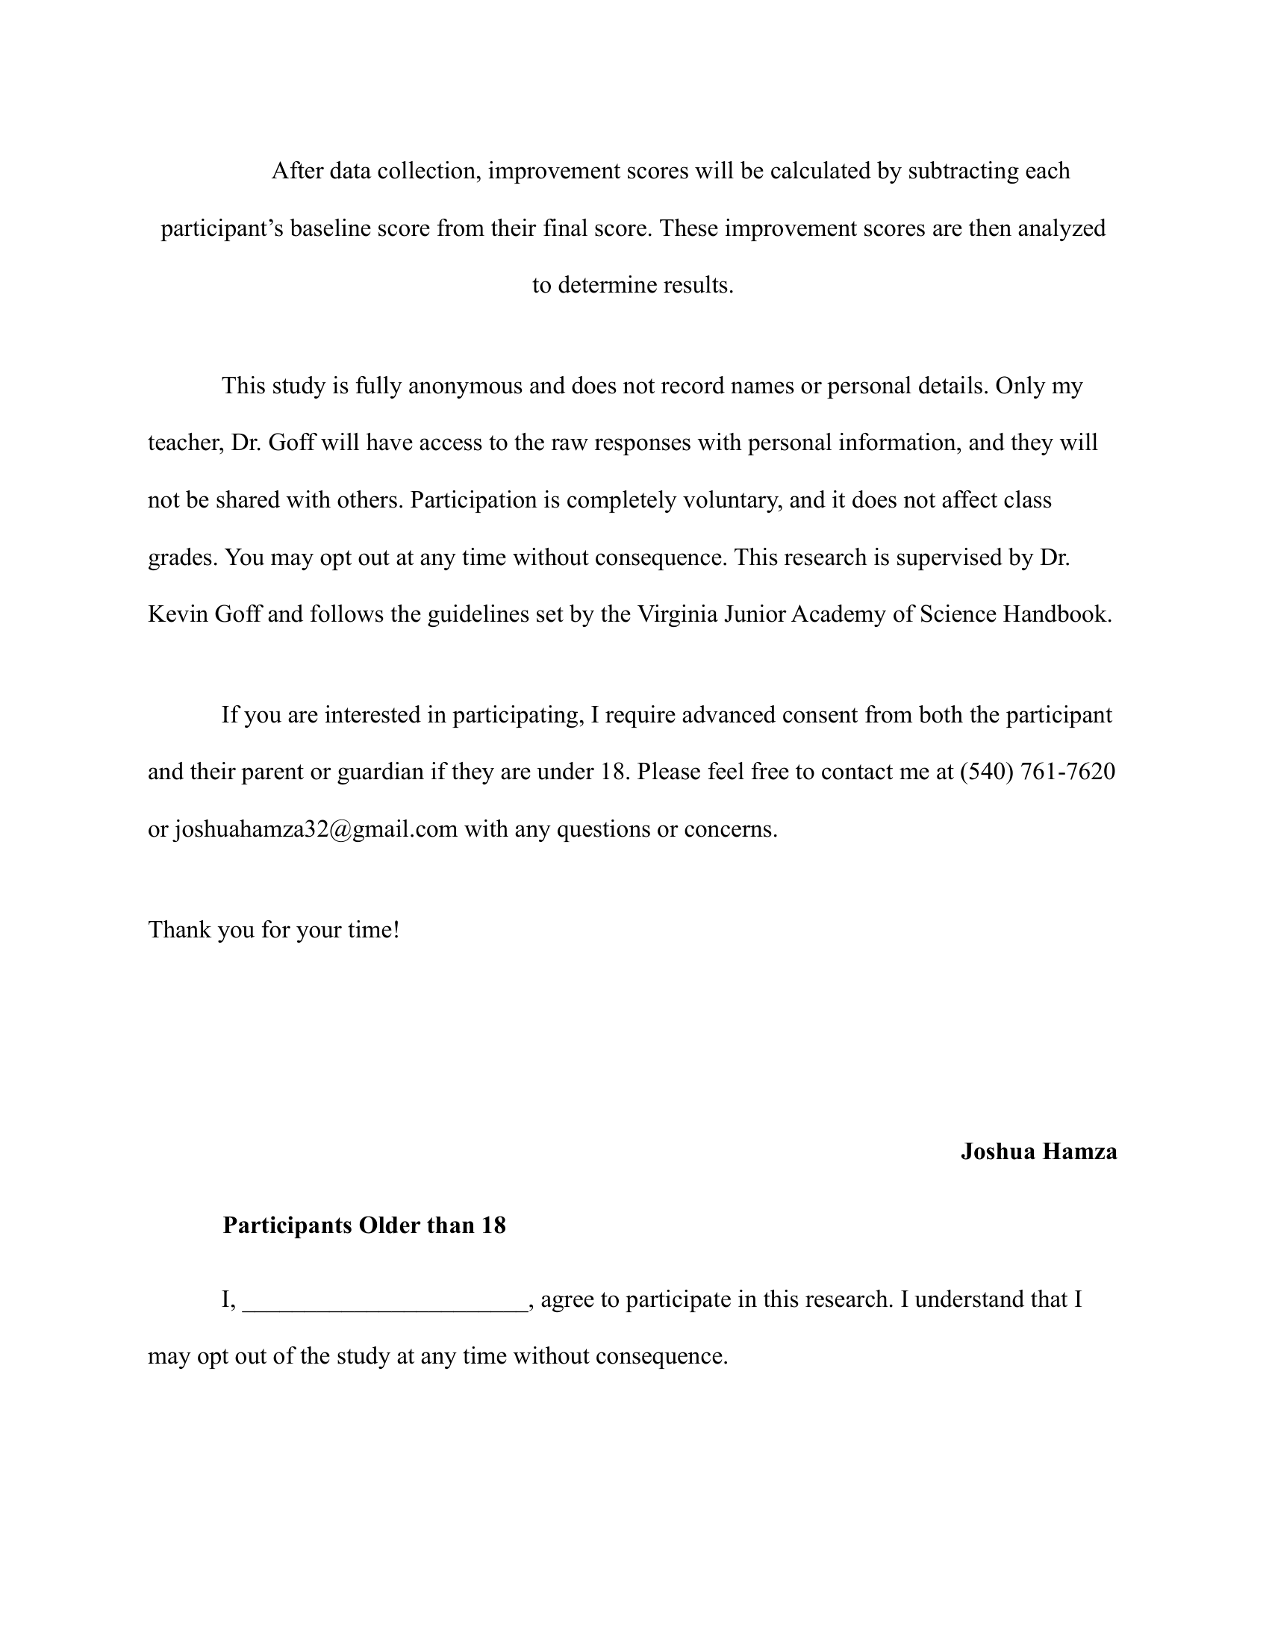
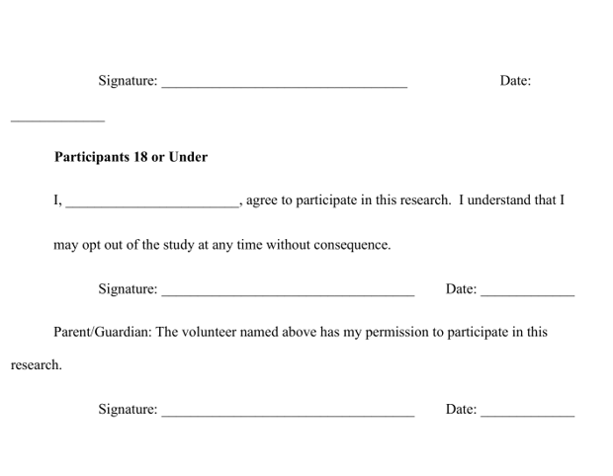
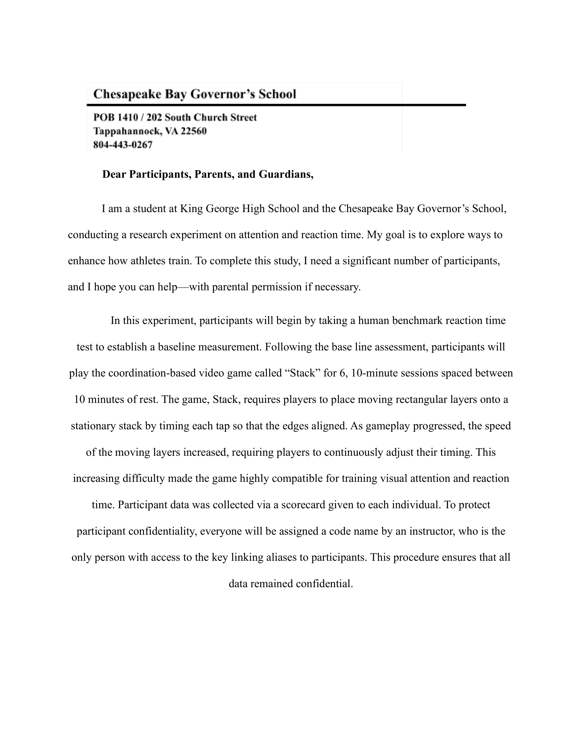
Figure 1: Consent form
RESULTS
After data collection, improvement scores were calculated by subtracting each participant’s baseline score from their final score. These improvement scores were then analyzed to determine results. A paired t-test was used to analyze differences between the before and after groups. At a sample size of 29 the mean baseline reaction time was 288.34 millisecond while the mean post-intervention reaction time was decreased to 281.03 millisecond. The paired-samples t-test revealed that this difference was not statistically significant, (p = 0.13). At a significance level of α = 0.05, the null hypothesis could not be rejected.

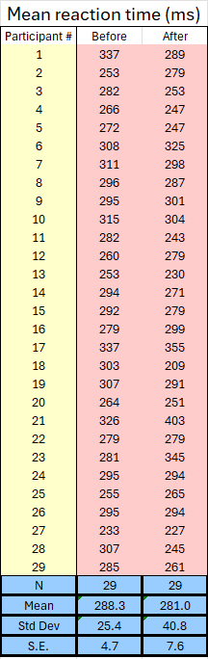
DISCUSSION AND CONCLUSIONS
Figure 2: Graph of mean reaction time before vs after video game practice

Table 1: Before vs After Reaction Times
This study aimed to determine whether playing a coordination-based video game ("Stack") could improve reaction time in participants. After the video game treatment, the average reaction time improved from 288.34 ms to 281.03 ms, showing roughly a 7 ms decrease. However, the paired-samples t-test showed that this difference was not statistically significant, p = 0.13 (one-tailed). At a significance level of α = 0.05, the null hypothesis could not be rejected.
While the results did not reach statistical significance, the 7 ms improvement is still worth considering. The data showed a moderate positive improvement between baseline and post-intervention scores. The increase in variance after the intervention suggests that participants responded differently to the video game training—some may have improved more than others.
There are several possible explanations for why the results were not statistically significant. First, the sample size of 29 participants may have been too small to detect a real effect. With more participants, the 7 ms improvement might have reached significance. Second, the intervention period of six 10-minute sessions may not have been long enough to produce noticeable changes in reaction time. It is possible that participants needed more practice time to develop improvements.
This study had several limitations. The sample was a convenience sample made up mostly of adolescents, which means the results may not apply to other age groups or the general population. Additionally, there was no control group, so it is unclear whether improvements came from the video game itself or simply from taking the reaction time test twice. The increased variance in the post-intervention scores could also indicate that factors like tiredness, motivation, or environmental distractions affected some participants more during the second testing session.
Despite these limitations, this study provides useful preliminary information. Given the trend toward improvement, it is reasonable to speculate that there may be some benefits to a subsequent study that has a larger sample size and occurs over a longer timespan to investigate the full effects of video games on training reaction time. This study could serve as a pilot study to allow researchers to design better experiments in the future.
Future studies should include a control group that does not play the video game, use a larger number of participants, and extend the training period to several weeks or months. It would also be helpful to test participants multiple times after the intervention to see if any improvements last overtime. Additionally, researchers could examine whether factors like previous gaming experience or age affect how much people benefit from video game training.
In conclusion, while this study did not find statistically significant evidence that playing the coordination-based video game improved reaction time, the observed 7 ms decrease suggests that video game training could possess some potential benefits. With improvements to the study design, future research may be able to better determine whether video games can effectively improve reaction time and other cognitive skills. Although this study did not find statistically significant evidence that playing the coordination-based video game improved reaction time, the observed 7 ms decrease and relatively low p-value (p = 0.13) suggest that video game practice may have the potential to enhance reaction time and, more broadly, aspects of cognitive function. This finding is consistent with prior research discussed in the Introduction, which reported cognitive benefits of video game training in populations such as older adults and individuals with cognitive impairments. Taken together, these results support the idea that video games may offer benefits beyond entertainment alone. With improvements to study design, future research may be better able to determine the extent to which video games can effectively improve reaction time and other cognitive skills.
Conclusion
This study found that playing the coordination-based video game “stack” produced a small but statistically insignificant improvement in reaction time, with average scores decreasing by approximately 7 ms. Because my p-value of 0.13 exceeded the acceptable p-value of 0.05, the null hypothesis could not be rejected. Limitations such as the small sample size, lack of a control group, and short duration of study might have contributed to this. Regardless, the observed trend suggests that video game training requires further investigation. Further studies with larger sample sizes, longer training periods and proper control groups would be better suited to determine whether coordination-based video games can improve reaction time.
LITERATURE CITED
Peer-Reviewed and Scholarly References
Ahn, H., & Won, J. (2023). The effects of adolescents’ participation in video games on cognitive function and motor control skills. ProQuest, 11(20), 2740. https://doi.org/10.3390/healthcare11202740
Choi, E., Shin, S.-H., Ryu, J.-K., Jung, K.-I., Kim, S.-Y., & Park, M.-H. (2020). Commercial video games and cognitive functions: Video game genres and modulating factors of cognitive enhancement. Behavioral and Brain Functions, 16(2). https://doi.org/10.1186/s12993-020-0165-z
Choi (2025). Narrative mobile video game-based cognitive training to enhance frontal function in patients with mild cognitive impairment. Scientific Reports, 15(1). https://doi.org/10.1038/s41598-024-84086-9
Shi, S., Cui, S., Yao, Y., Ge, M., Yang, M., Sheng, X., Luo, B., Yang, Y., Yuan, X., Zhou, X., Liu, H., & Zhang, K. (2023). Smartphone video games improve cognitive function in patients with chronic schizophrenia: A randomized controlled trial. European Archives of Psychiatry and Clinical Neuroscience, 274(4). https://doi.org/10.1007/s00406-023-01660-4
Yang, C., Han, X., Jin, M., Xu, J., Wang, Y., Zhang, Y., Xu, C., Zhang, Y., Jin, E., & Piao, C. (2021). The effect of video game–based interventions on performance and cognitive function in older adults: Bayesian network meta-analysis. JMIR Serious Games, 9(4), e27058. https://doi.org/10.2196/27058
Non-Peer-Reviewed and Scholarly References
(none)

